
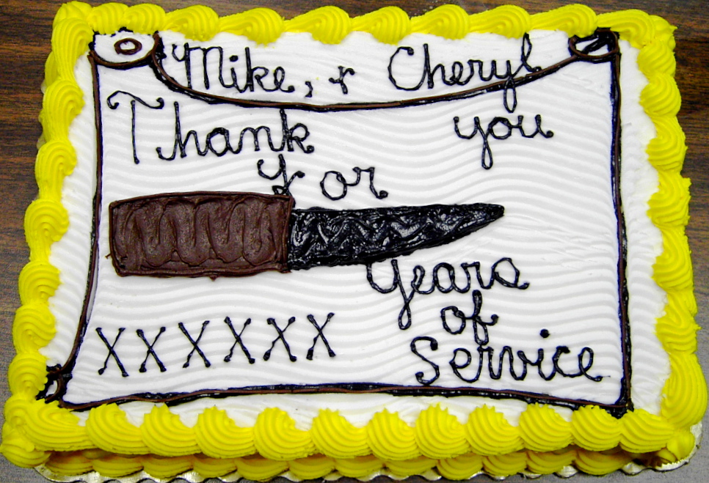
November 2008
Flint River Knife Club
mullikim@earthlink.net

NOVEMBER 11 is an IMPORTANT MEETING: The Club will hold election of officers, collect annual club dues and payment of the club knives, and hold the low-numbers drawing for the 2008 and 2009 club knives. No other business will be conducted at this meeting!

REMINDER: Club dues are $25 per person and $15 for a spouse. Club Knives are $60 each, with a limit of two per member.

BENEFIT KNIFE: The knife and cutting board have been completed. The knife, made by Wayne Hensley, has been previously described. The cutting board, crafted by David Prowell, is itself a work of art -- made up of Oak, Mahogany and Walnut woods, with a magnetic knife holder on the side and rubber feet on the bottom of the board. It measures 12 x 16 inches -- it would make a beautiful gift! 200 tickets are available to sell at $10 a piece. What a steal! Get yours now! The drawing for the knife will be in February 2009.

ANNUAL CHRISTMAS DINNER: Mama Mia’s, an Italian restaurant in Stone Mountain, was chosen for the dinner’s location. The date is Tuesday, December 2 at 7 pm. The address for the restaurant is 961 Main Street, Stone Mountain, GA 30083.

Since the Club is not having a knife show this year, and its bank account is not being replenished by any other fundraiser this year, the Club decided at the last meeting that each person would pay for

their own meal. The approximate cost per meal will be $18.00, including
dessert. The food is reported to be delicious, so jump start the Christmas season by bringing family and friends for a relaxing evening!

PROGRAM: Rade Hawkins presented the program for the October meeting. His topic was “Knife Blade Steel.” He asked, “What is the perfect steel?” His answer was, “There isn’t one. Like everything in life, there are tradeoffs. To gain one property, you usually have to give up something else.” He went on to tell the club about the 4 major groups of steel and their differences: Straight Carbon Steel, Stain Resistant Steel, Powdered Metal Steel and Maraging Steel (an exotic blend of alloys, primarily nickel and cobalt). Rade gave an informative presentation, and took questions from the floor. All in all, I’d have to say, his presentation was far sharper than his knife blades!



