
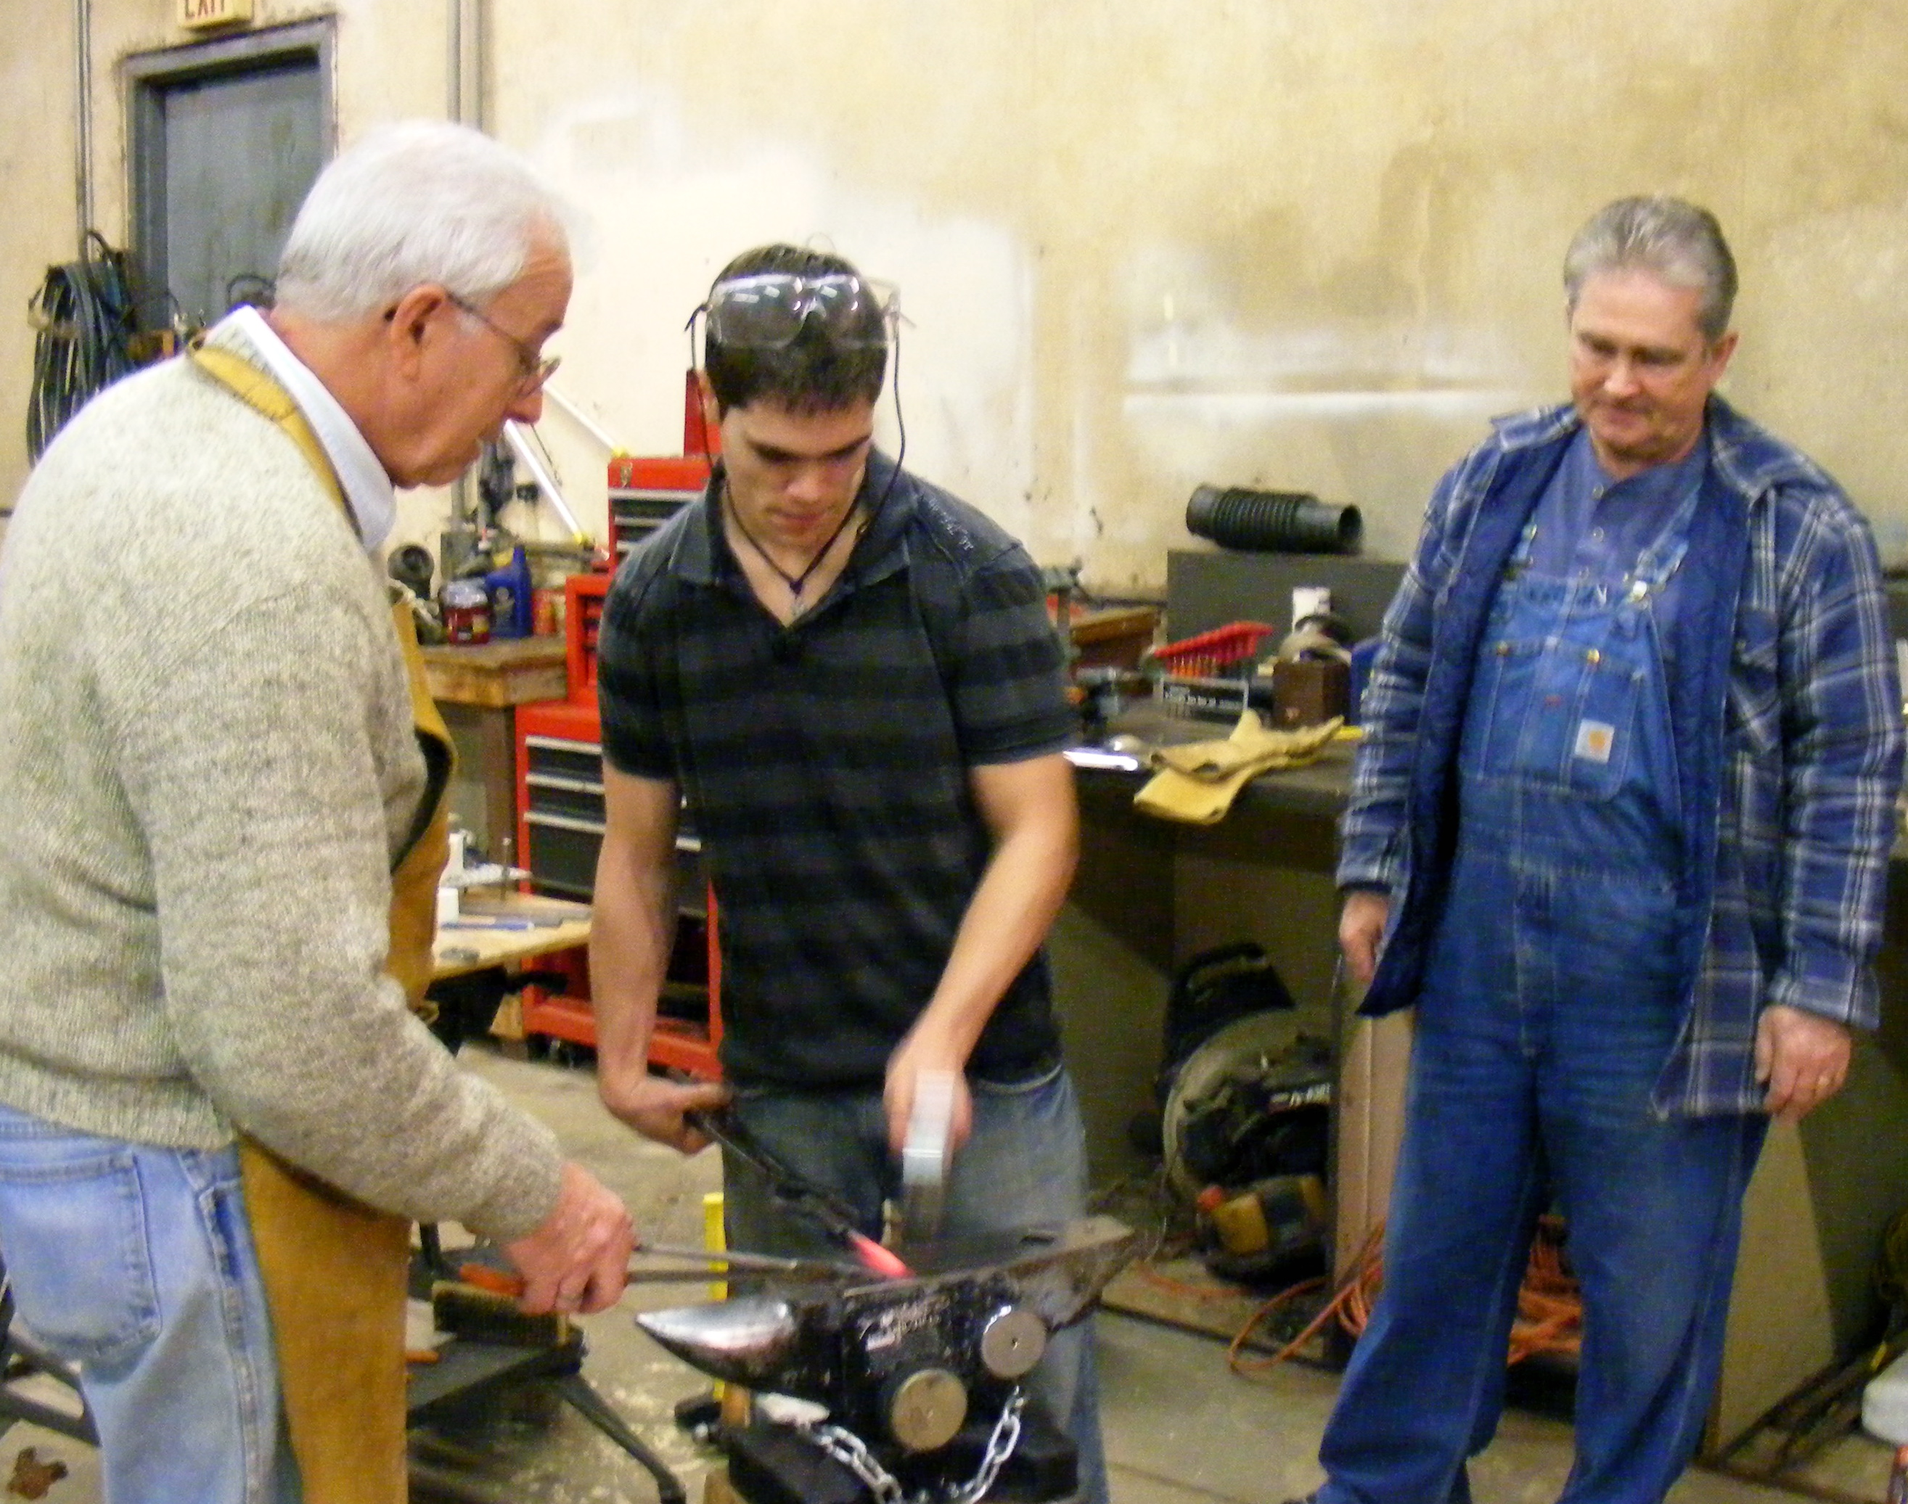
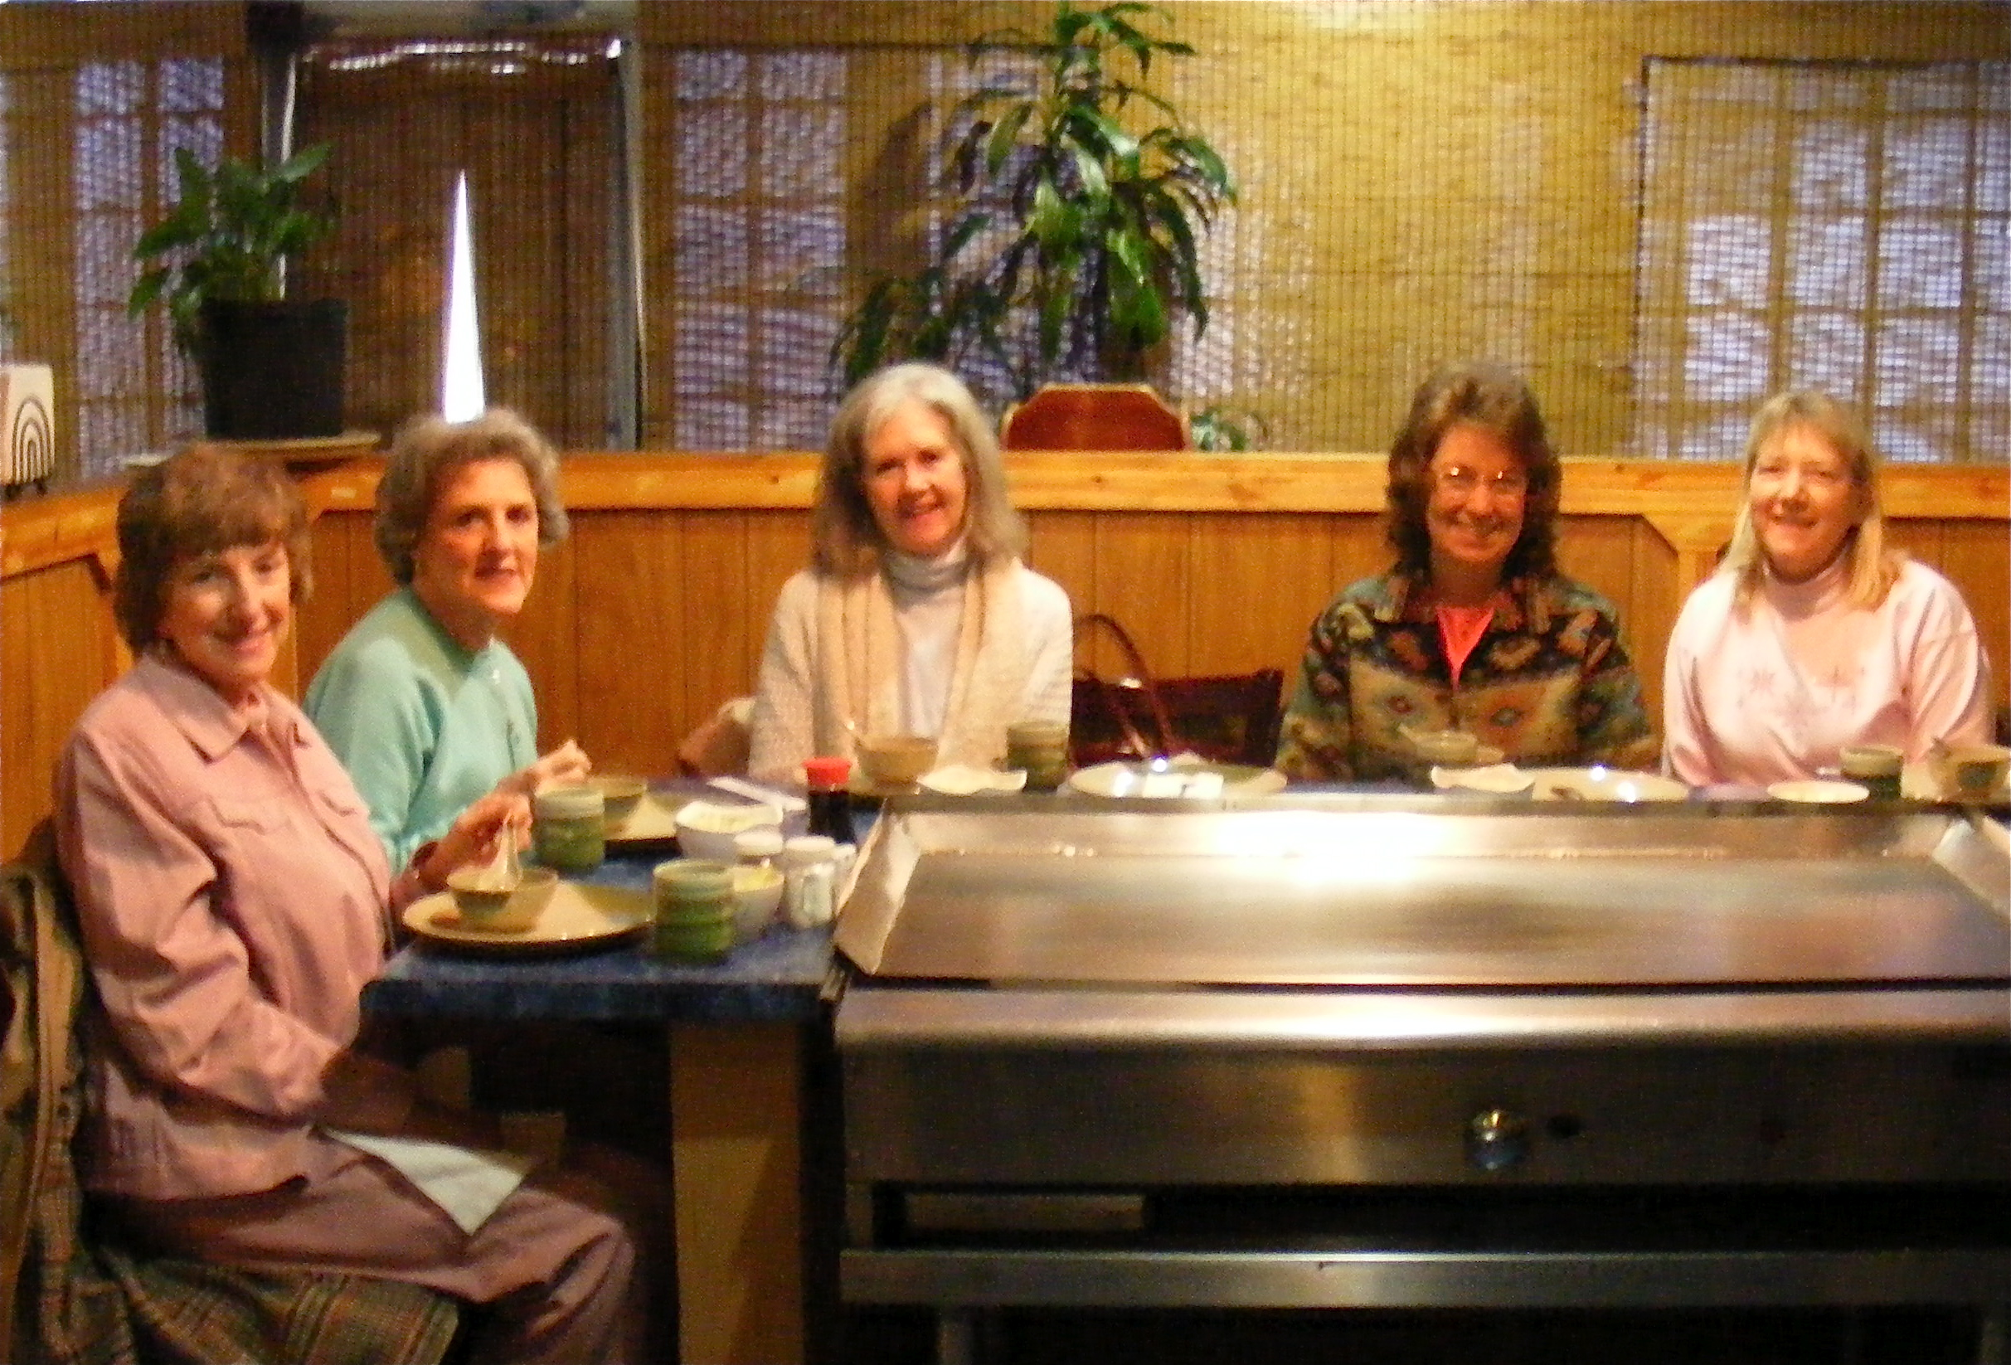
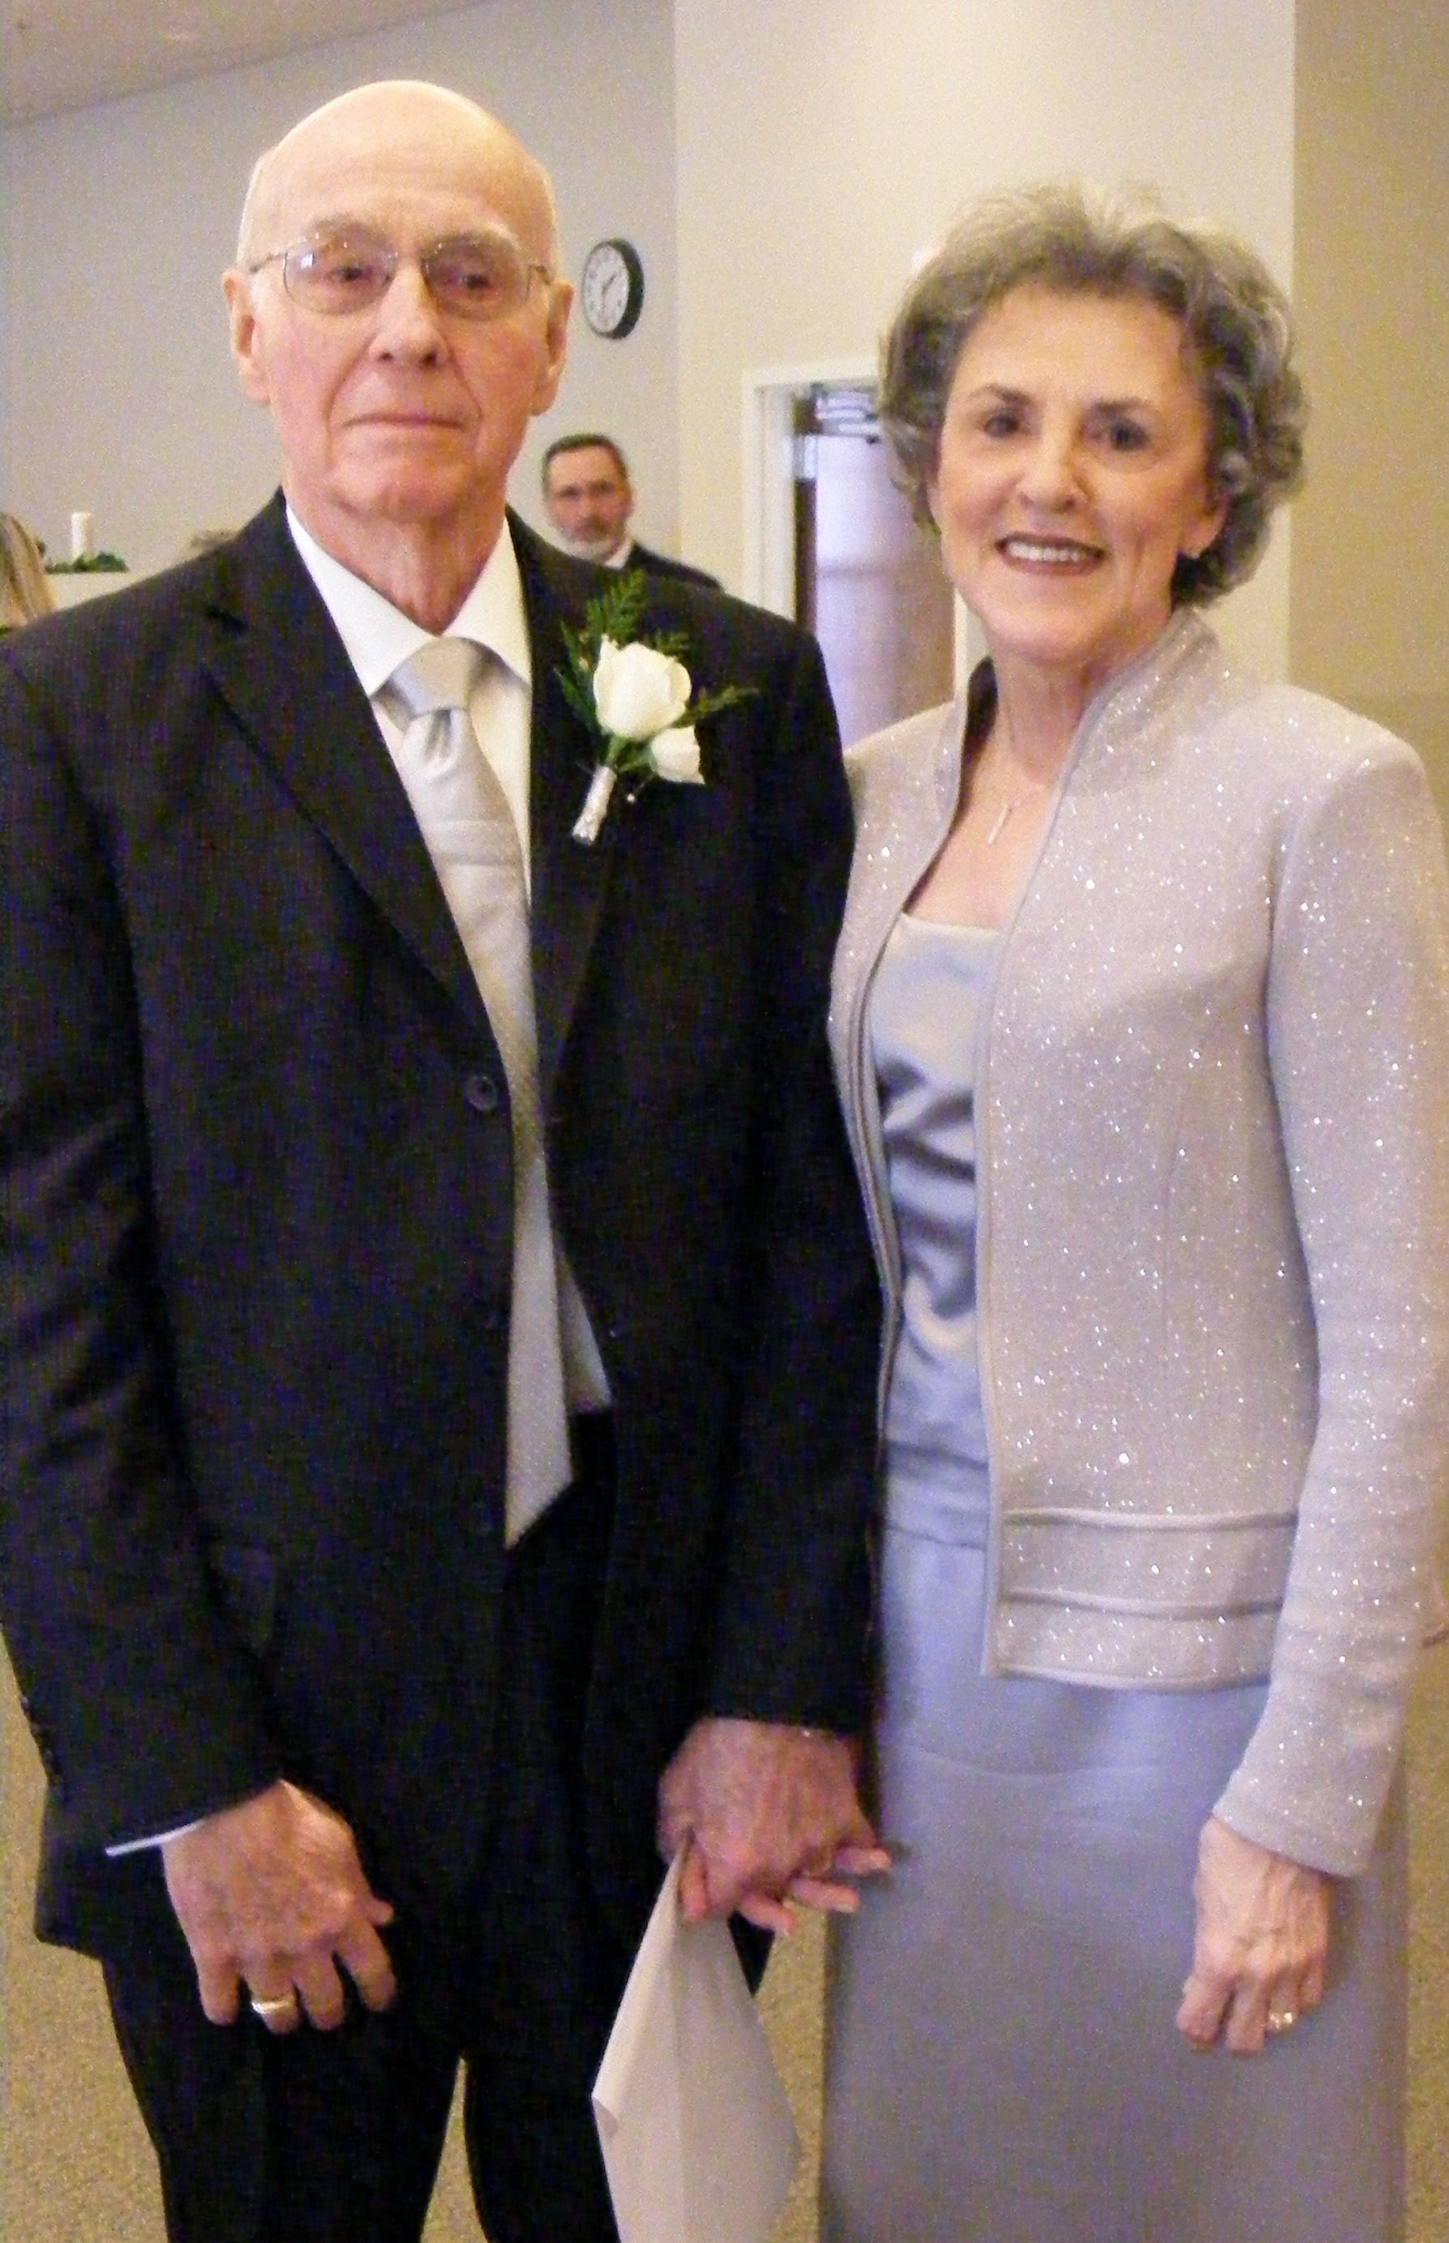
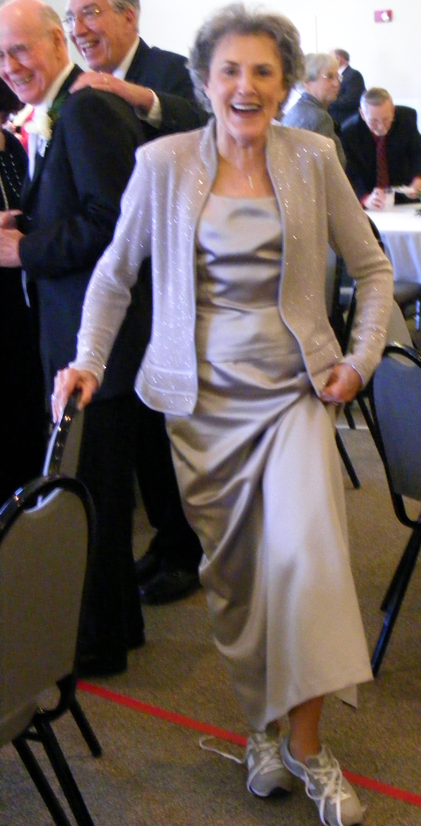
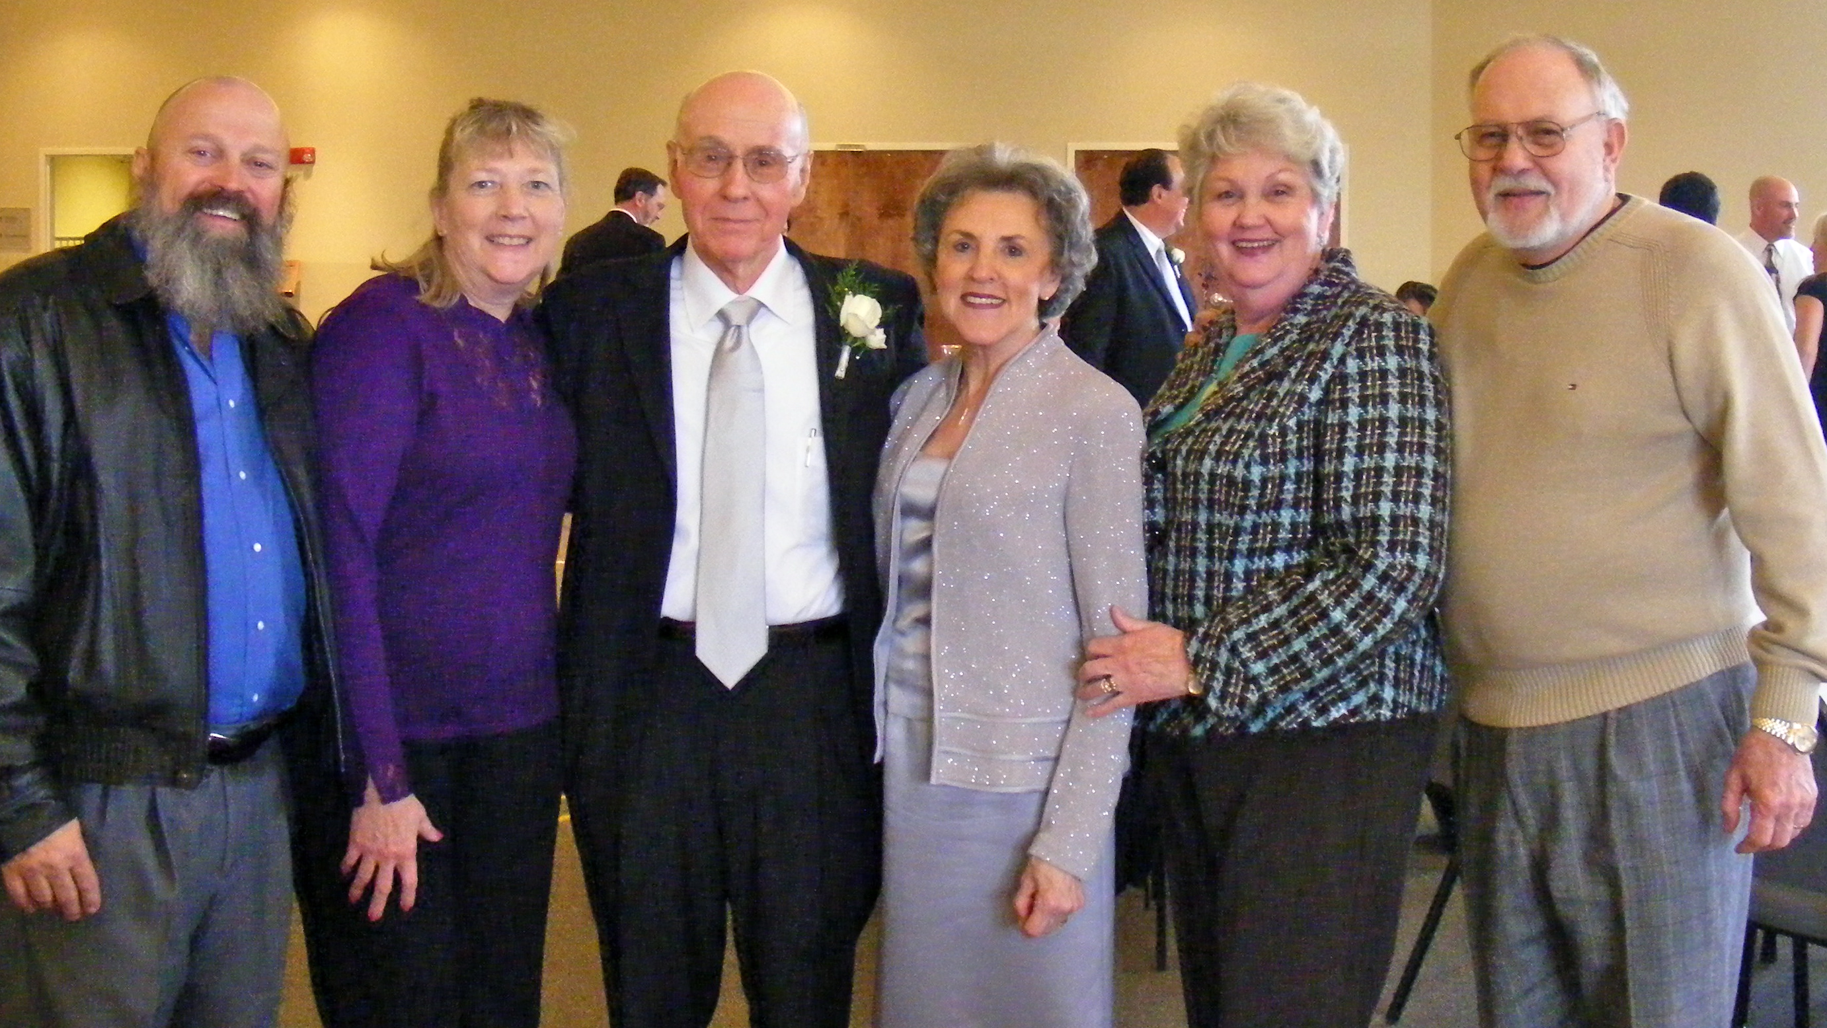
March 2010
Flint River Knife Club
mullikim@earthlink.net
The HAMMER-IN at Jerry Costin’s shop on January 30 was enjoyed by all! The fellows had a cook-out while the ladies went out to eat at a Japanese restaurant in Conyers.

CHERRY BLOSSOM FESTIVAL Our club was approved for two spots at the Cherry Blossom Festival, on March 27 - 28 at the International Horse Park in Conyers. We will have forging and grinding demonstration set-ups for the festival. We hope to promote our club and invite people to come to the meetings.

Workers are needed for both days. The shifts are: Saturday, 12-2:30 and 2:30-5; Sunday, 10-12, 12-2:30 and 2:30-5. Please email Nola Costin at nolacostin@bellsouth.net to let her know when you can work or, if you do not have email, call Jerry Costin at 770-597-0113.
NO MEETING on Tuesday, Mar. 2. Instead there will be a club outing at Jerry Costin’s shop on Saturday, Mar. 6. It will begin at 9:30 am. There will be a guest speaker and lunch will be provided. Our regular business meeting will be held at 1 pm to make our plans for the Cherry Blossom Festival.

The Big
Event!

