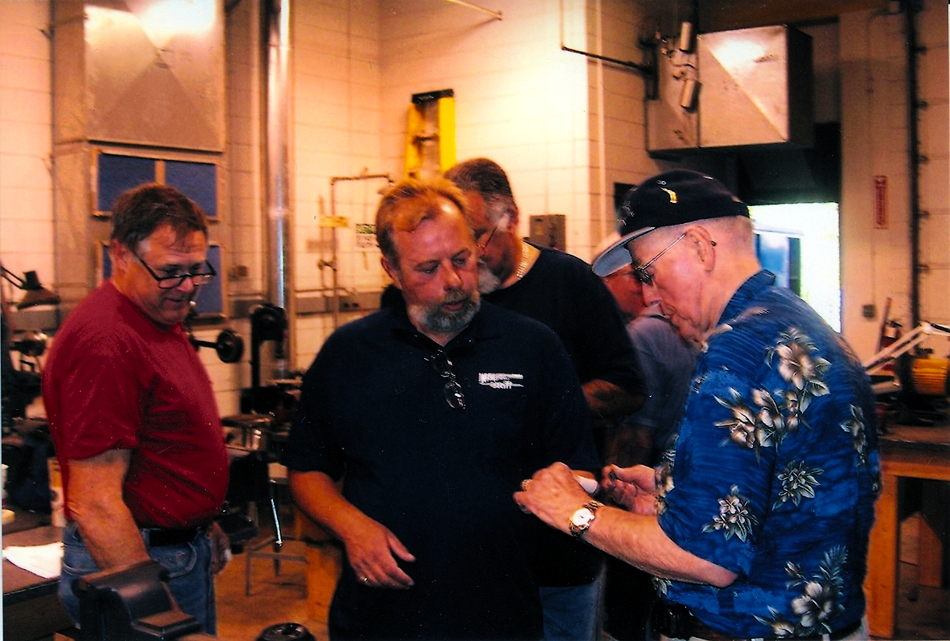

July 2007
Flint River Knife Club
mullikim@earthlink.net
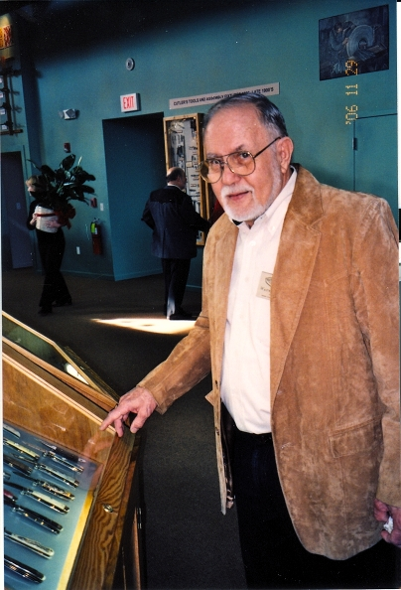
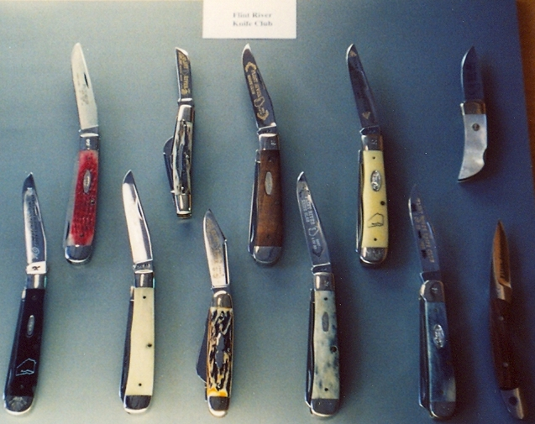
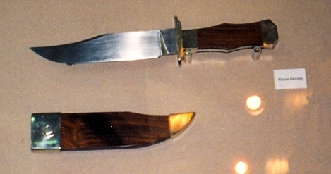
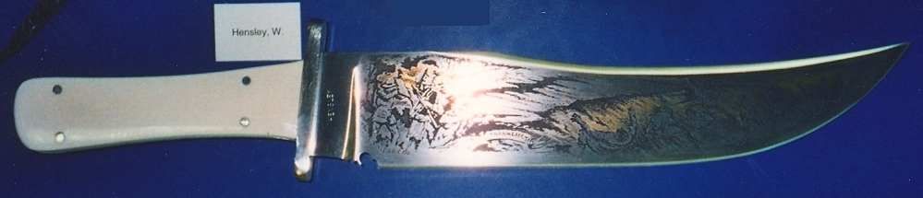
David Prowell and Jim Ragsdale at Mongomery Community College in Troy, NC.
Wayne Hensley at the National Knife Museum
Hensley hunter at the museum
Hensley Bowie at the museum
THE GREAT SOUTHERN KNIFE SHOW
The win-a-knife postcard drawing at the recent Blade Show netted us 100 postcards to mail out for the GSKS in October. The winner of the drawing was Shirley Casalena of Bel Air, Maryland.. A big thank you to all those who handed out cards at the Blade Show!

PROGRAM PRESENTATION: Jim Ragsdale told the club about his recent trip to the Mongomery Community College in Troy, NC. He, along with David Prowell and Jack Jackson, took a class on making folders, taught by Ed and Tanya Van Hoy; Jim was taking this class on scholarship from the club. There were 12 in his class, which lasted for 4 days. He said he basically learned to “heat, treat and then grind!” He started with 1 piece of steel, 2 pieces of titanium and 2 pieces of handle material. Jim said that he did a “liner-lock,” a first ever for him. It was an informative and interesting presentation. Thank you, Jim!

NEXT MEETING
Tuesday, July 3rd

Our club knives at the National Knife Museum

