
CLUB PICNIC:
July 2006
Flint River Knife Club
mullikim@earthlink.net
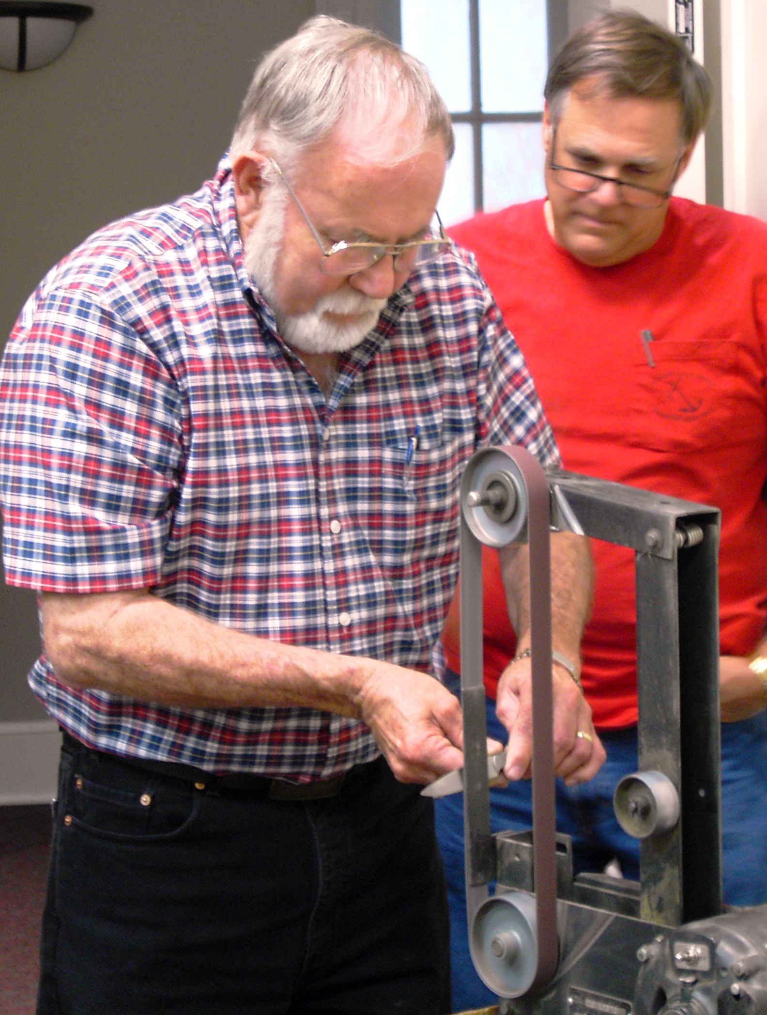
In lieu of a July meeting, there will be a club picnic Saturday, July 8, at David Prowell’s place in Fairburn, from 9 am – 5 pm. In the morning, Dan Tull will do a coal forge demonstration and in the afternoon, you can either do knife grinding or put a handle on a finished blade.

Bring a covered dish and your own lawn chair. The club will provide meat, drinks and dinnerware. Also, bring a knife to work on and equipment or supplies that you’d like to sell. Directions are on a separate attachment with this newsletter.

Friends and family members are welcome. Let David know by July 1 how many are in your party. His number is: 770-964-7636 or 770-366-6511.

BENEFIT KNIFE:
For the Great Southern Knife Show: Billy Bates will engrave the knife and, in appreciation, the Club will provide him a table free of charge at the show and a complimentary club membership.

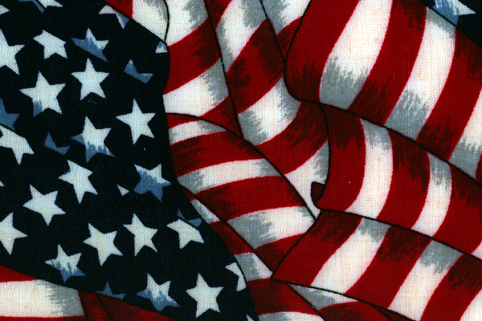
CLUB EQUIPMENT:

Happy
Birthday
America!
R.J. Adams is no longer making knives and the club has acquired all of his equipment for use at club events, like the upcoming picnic. Now, we just need a 5 ft. x 8 ft. covered trailer to haul it in – so keep alert and let David Prowell know if you know of a trailer for sale.

MEETING PROGRAM: Wayne Hensley presented a program at the June meeting on Knife Sharpening. He had a belt grinder set up in the meeting room and demonstrated how to grind the edges of various blades. He also had several types and sizes of stones that he used in his demonstration.

